DAY 4(18/7/2020)

LETSUPGRADE JAVASCRIPT ESSENTIALS

NAME : K KAVYA

EMAIL : [kavya.kguru@gmail.com](mailto:kavya.kguru@gmail.com)

Question 1: Create a for loop that iterates up to 100 while outputting "fizz" at multiples of 3, "buzz" at multiples of 5 and "fizzbuzz" at multiples of 3 and 5.

Code:

<html>

  <head>

    <h1>FIZZ BUZZ PROGRAM :)</h1>

  </head>

  <body>

    <script>

      for ( var i = 1; i <= 100; i++ )

      {

        if ( i%3 === 0 && i%5 === 0 )

        {

          console.log( i + " FizzBuzz" );

        }

        else if ( i%3 === 0 )

        {

          console.log(i+ " Fizz" );

        }

        else if ( i%5 === 0 )

        {

          console.log(i+ " Buzz" );

        }

        else

        {

          console.log(i);

        }

      }

    </script>

  </body>

</html>

OUTPUT:

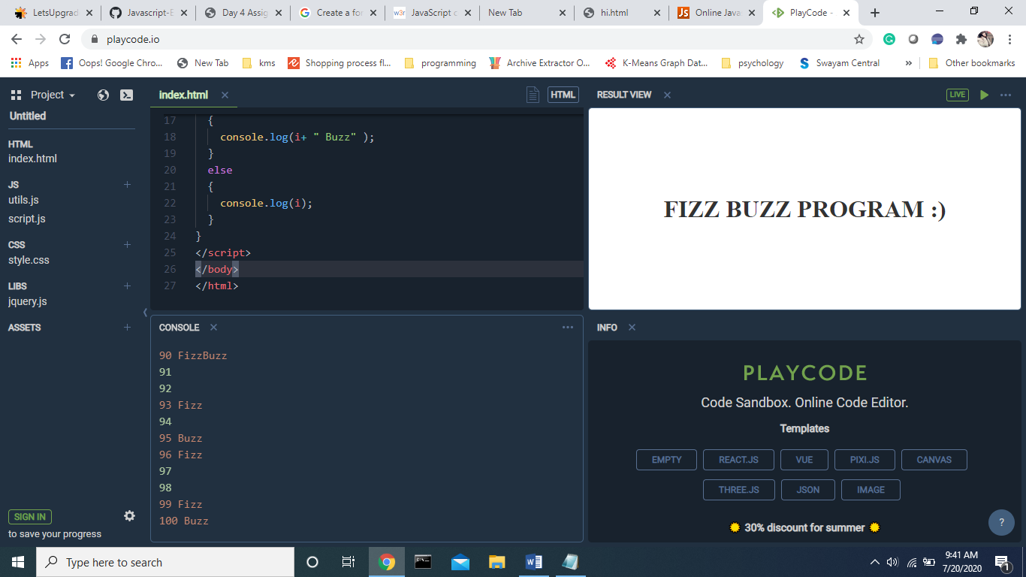

Question 2: Destructure the following object

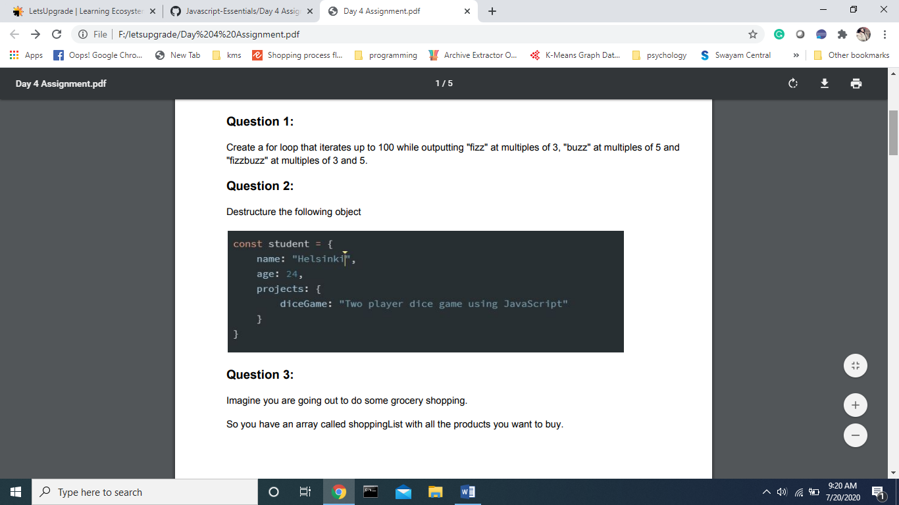

let student = {

  name: "Helsniki",

  age: 24

  project: "dicegame-two player dice game using js"

  };

 let {name,years: age, project} = student;

alert( name );

alert( age );

alert( project );

Question 3: Imagine you are going out to do some grocery shopping. So you have an array called shoppingList with all the products you want to buy.

Now that you are inside of the shop, you have a basket with all the products from your list, but you want to add a few more. Create a new array called shoppingBasket, that will be a copy of the shoppingList array, and add some new products into it.

let fruits = ["Apples", "Pear", "Orange"];

let shoppingCart = fruits;

shoppingCart.push("peach");

console.log(shoppingCart);

console.log( fruits.length ); *// 4*

output:

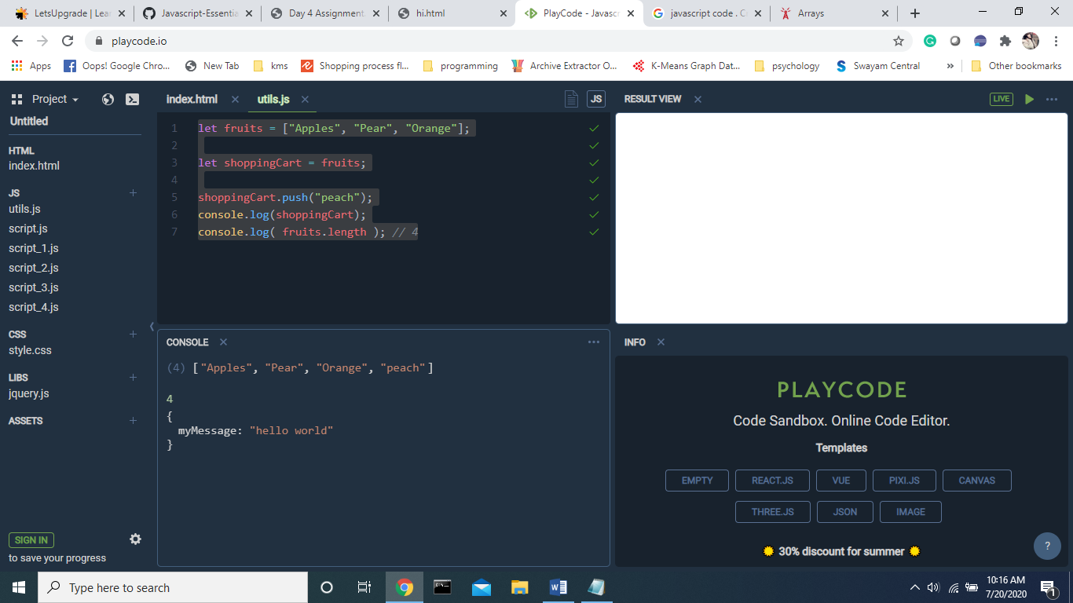

Question 4: Make a Calculator in Javascript which can do operations as Addtion, Subtraction, Multiplication, Division, Square root, Percentage.

<html>

  <head>

    <meta charset="utf-8" />

    <title>

      JavaScript program to calculate multiplication and division of two numbers

    </title>

    <style type="text/css">

      body {margin: 30px;}

    </style>

  </head>

  <body>

    <form>

      1st Number : <input type="text" id="firstNumber" /><br />

      2nd Number: <input type="text" id="secondNumber" /><br />

      <input type="button" onClick="multiplyBy()" value="Multiply" />

      <input type="button" onClick="divideBy()" value="Divide" />

    </form>

    <p>

      <br>

      <br>

     The Result is :

      <br />

      <br/>

      <span id="result"></span>

    </p>

  </body>

</html>

Js code :

function multiplyBy() {

  num1 = document.getElementById('firstNumber').value;

  num2 = document.getElementById('secondNumber').value;

  document.getElementById('result').innerHTML = num1 \* num2;

}

function divideBy() {

  num1 = document.getElementById('firstNumber').value;

  num2 = document.getElementById('secondNumber').value;

  document.getElementById('result').innerHTML = num1 / num2;

}

Ouput :

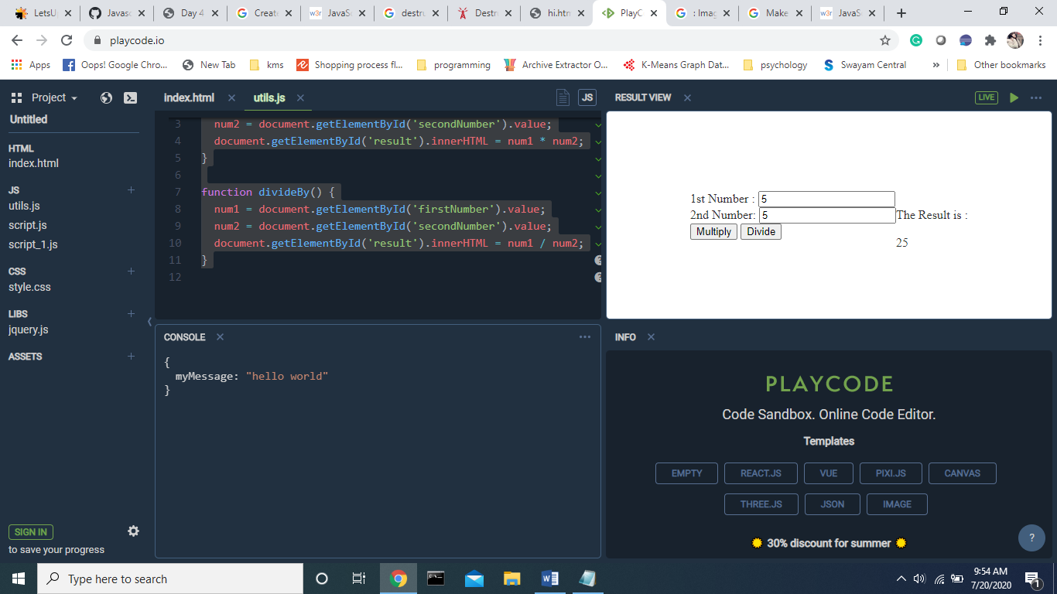

Question 6: Rewrite the function using '?' or '||' Write a loop which prompts for a number greater than 100. If the visitor enters another number – ask them to input again. The loop must ask for a number until either the visitor enters a number greater than 100 or cancels the input/enters an empty line. Here we can assume that the visitor only inputs numbers. There’s no need to implement a special handling for a non-numeric input in this task.

let num;

do {

  num = prompt('Enter a number greater than 100?', 0);

} while (num <= 100 && num);

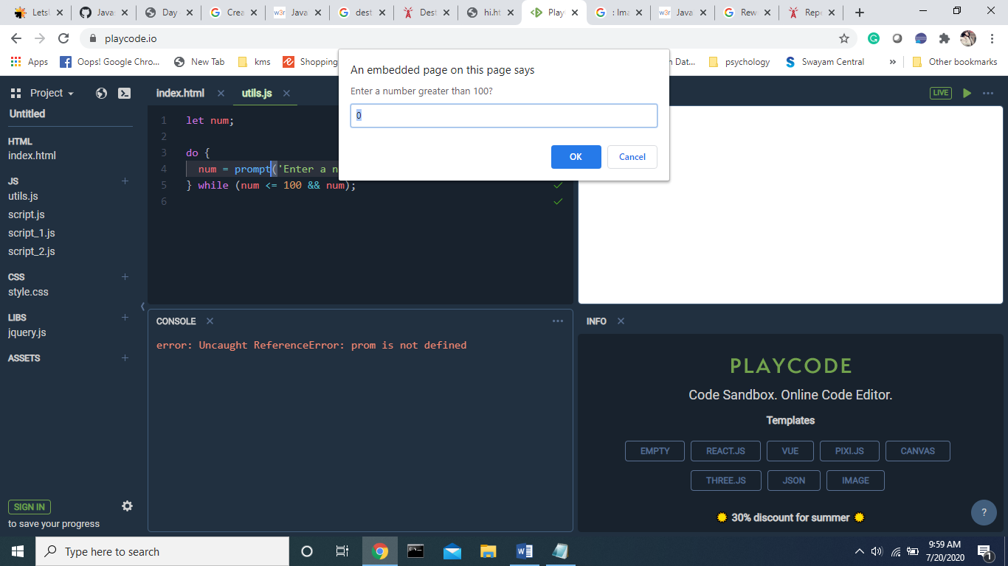

Question 7: An integer number greater than 1 is called a prime if it cannot be divided without a remainder by anything except 1 and itself. In other words, n > 1 is a prime if it can’t be evenly divided by anything except 1 and n. For example, 5 is a prime, because it cannot be divided without a remainder by 2, 3 and 4.Write the code which outputs prime numbers in the interval from 2 to n. For n = 10 the result will be 2,3,5,7. P.S. The code should work for any n, not be hard-tuned for any fixed value

let n = 20;

outer: for (let i = 2; i < n; i++) {

    inner: for (let j = 1; j < n; j++) {

        while (j>1 && j<i) {

            if (i%j == 0 ) {

                continue outer;

            } else {

              continue inner;

            }

        }

    }

    console.log(i);

}

Output:

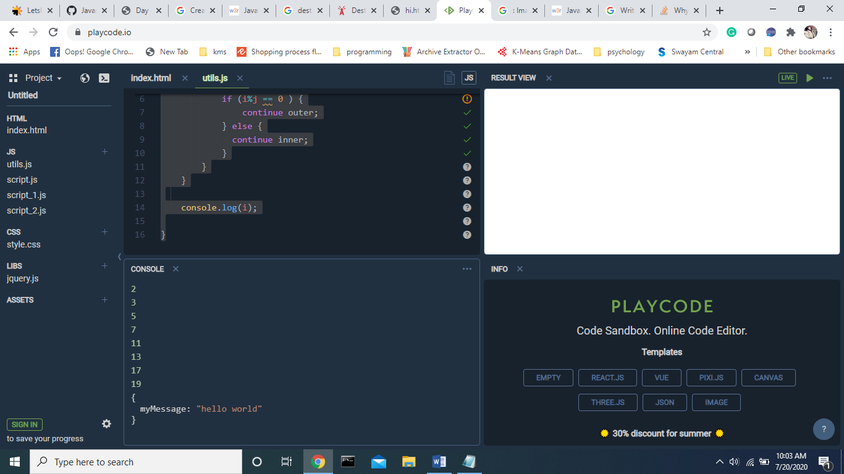

Question 8: Replace Function Expressions with arrow functions in the code below:

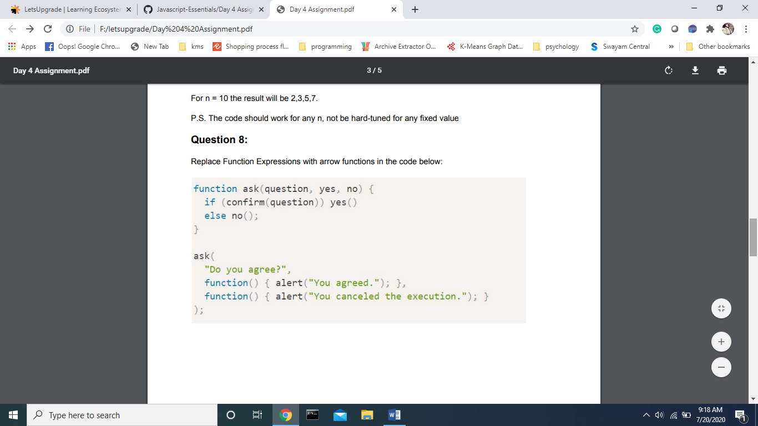

function ask(*question*, *yes*, *no*) {

  if (confirm(question)) yes()

  else no();

}

ask(

  "Do you agree?",

  () => alert("You agreed."),

  () => alert("You canceled the execution.")

);

